Project Overview and Objective:
To analyze daily rainfall data to identify maximum and minimum of rainfall with days. To identify district – wise difference in rainfall and visualize rainfall data using tools like Excel and Power BI. The objective of the rainfall dataset is to analyse historical rainfall data to understand rainfall patterns, seasonal variations, and extreme events, and to support better planning and decision-making in areas such as water management, agriculture, and disaster preparedness.
Data Source:
Source Description and Timeline: India data Portal
Source Link: https://indiadataportal.com/p/climate-data/r/wris-daily_rainfall_district-dt-dl-imd
Dataset Topic: Daily Rainfall Dataset in District-wise (2007 to 2024)
Format: CSV file
Problem Statement:
- The purpose of this project is to analyze daily rainfall data to understand rainfall patterns, seasonal behavior and extreme events using data analytics tools.
- The insights obtained can support better planning in agriculture, water management and disaster mitigation.
Attribute (Column /Features) Details:
Attribute Name | Data type | Description
Date | Date (DD/MM/YY) | Represents the day when rainfall was measured in each district.
State Code | Numeric (Integer) | Identify states uniquely
State Name | String (Text) | Name of the States
District Code | Numeric (Integer0 | Identify district uniquely
District Name | String (Text) | Name of the District
Actual Rainfall (millimetre) | Number (Decimal) | Measured using rain Gauges (or) Shows the observed Rainfall
Rainfall Storage | Number (Decimal) | The quantity of rainwater stored in water bodies (or) ground water system during a specific period
Normal Rainfall | Number (Decimal) | The long-term average rainfall for a specific location and period, based on historical records
Percentage Deviation from Normal | Number (Decimal) | Indicates excess or deficit rainfall, help understand weather anomalies
Tools and Technologies:
- Excel: Data cleaning, transformation, and Pivot Tables.
- Power BI: Data modelling, DAX calculations, visualization, and interactive dashboard creation.
Data Pre-Processing (Excel / Power Query):
Task Performed:
- Data Cleaning and Transformation
- Remove Duplicates, handle missing values on Actual, Storage , Normal Rainfall Column Using AVERAGE function.
- State name and District name using TRIM and CLEAN, PROPER function
- Percentage Deviation from Normal column using formula:
Percentage Deviation = (Actual Rainfall – Normal Rainfall)/Normal Rainfall * 100
- Filtering and Sorting: Organized data to focus on Relevant (State name) Records.
- Using XLOOKUP function.
- Convert to data into one fact table and two dimensions table (State and District).
- Pivot Tables:
State vs Count of Actual
State vs sum of Normal (Date)
Date(yr) vs District Name
- Descriptive Statistics:
Descriptive (Normal Rainfall)
Descriptive (Rainfall Storage)
Data Modelling and DAX (Power BI):
Date model:
- Get date from excel Select Daily Rainfall (cleaning), Date (yr) vs District Name, Dimensional (State), Dimensional (District), Fact Table, State vs Sum of Normal (Date) and State vs Count of Actual Rainfall load and Transform Data
- Select Date(yr) vs District Name change type Go to transformuse first row in headers
- Select State vs Count of Actual Rainfall Add columnConditional column New columnName: Rainfall Status

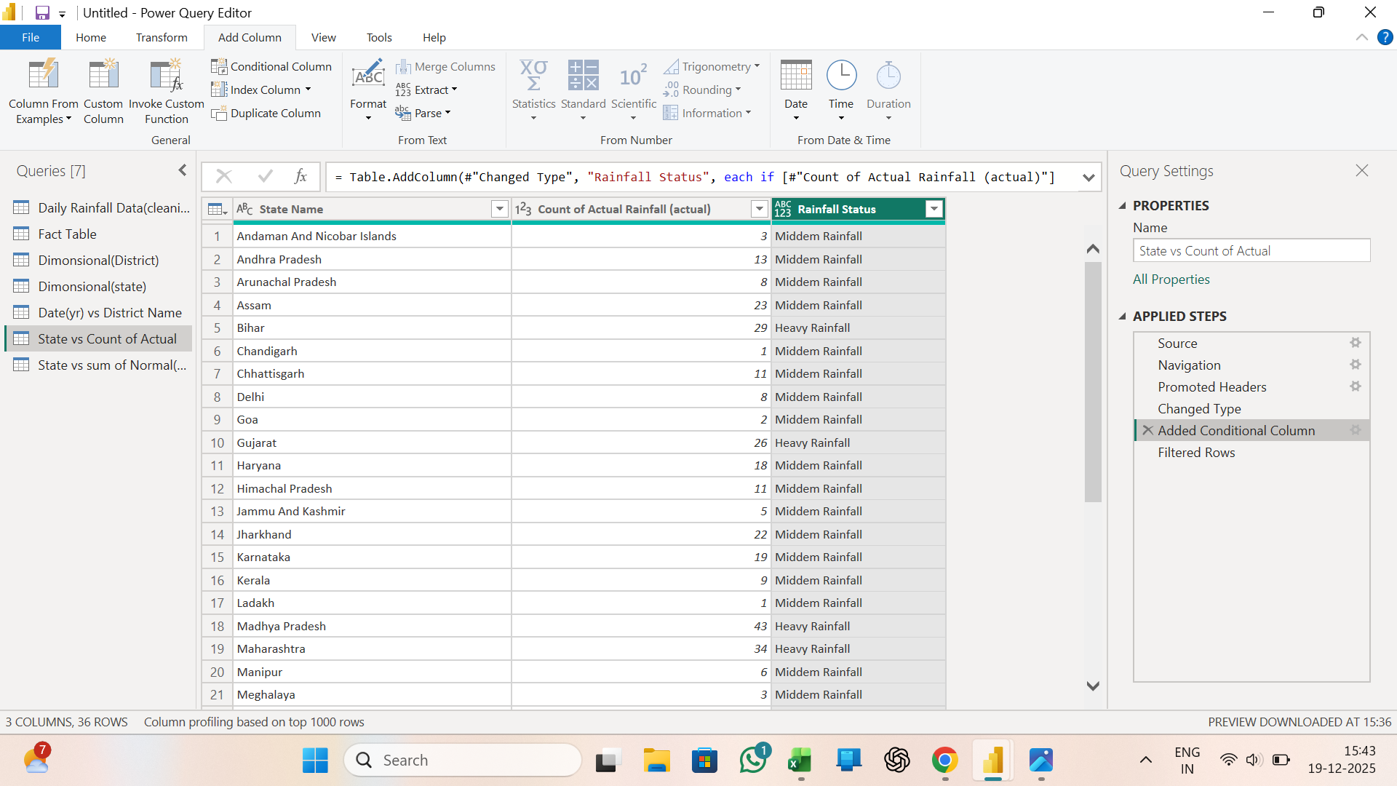

- Mange Relationship:
Goto model view Mange relationshipuse one to many, many to many functions.
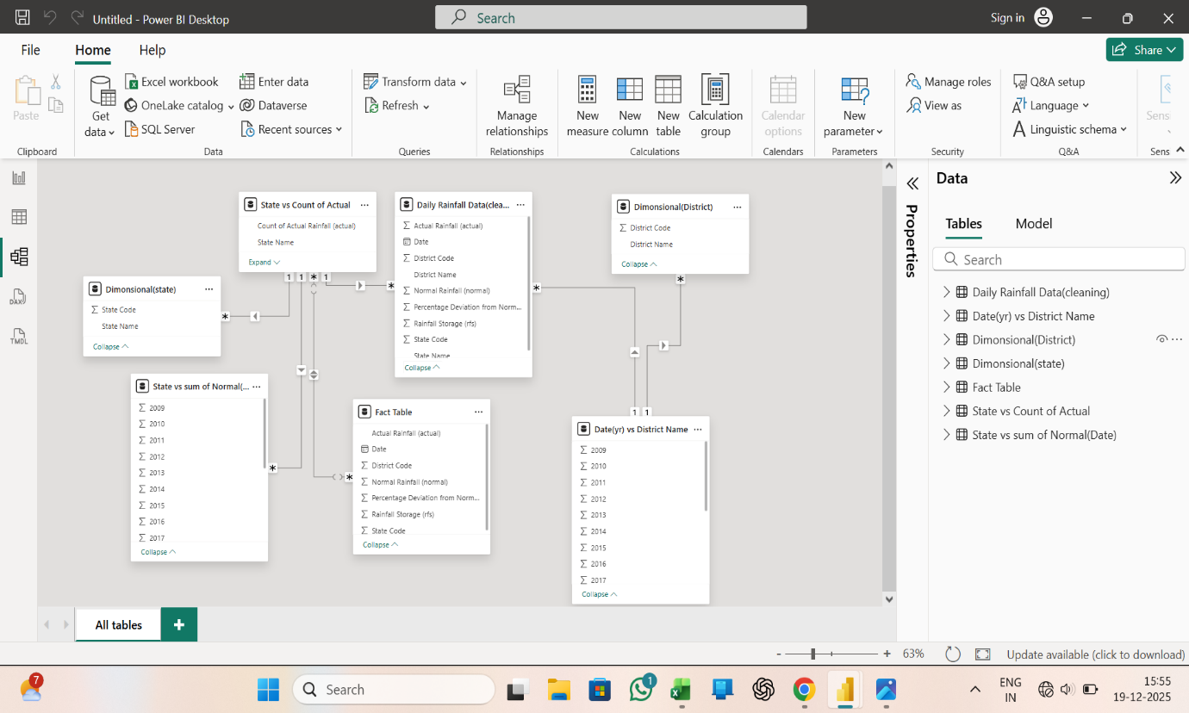

Calculated New Measure Formula’s:
Goto Report view Select Daily rainfall data(cleaning) Table toolsNew measureFormula bar using formulas:
- State count” State-Count = sum ('Daily Rainfall Data(cleaning)'[State Code])”
- District count” District-Count = sum ('Daily Rainfall Data(cleaning)'[District Code])”
- Max of Rainfall storage” Max of Rainfall Storage = MAX ('Daily Rainfall Data(cleaning)'[Rainfall Storage (rfs)])”
- Average of percentage Deviation” Average of Percentage Deviation = AVERAGEA ('Daily Rainfall Data(cleaning)'[Percentage Deviation from Normal (deviation)])”
- Mathematical function” Math fun = power (3,2)”
- QTY-YTD Function” QTY_YTD = CALCULATE (sum ('Daily Rainfall Data(cleaning)'[Rainfall Storage (rfs)]),'Daily Rainfall Data(cleaning)'[Date])”
- Total-YTD ” Total YTD = TOTALYTD ('Daily Rainfall Data(cleaning)'[Average of Percentage Deviation],'Daily Rainfall Data(cleaning)'[Date])”
- Month-in-date” Month in date = MONTH ("23-12-2020")”
- Total actual rainfall” Total Actual Rainfall = COUNT ('Daily Rainfall Data(cleaning)'[Actual Rainfall (actual)])”
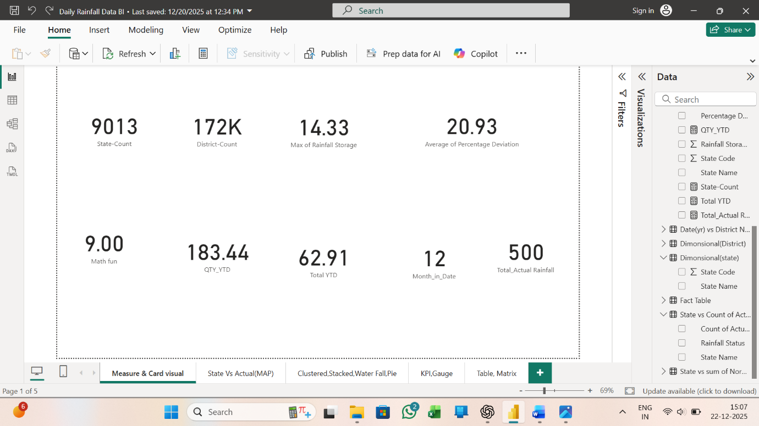

Calculated New column Formula’s:
Goto Report viewselect Table daily rainfall data(cleaning)Table toolsNew columnFormula bar using Formulas:
- Mathematical function (Normal Rainfall):” math fun(normal) = ROUND('Daily Rainfall Data(cleaning)'[Normal Rainfall (normal)],2)”
- Extract Left (4):” Extract Left (4) = left ('Daily Rainfall Data(cleaning)'[State Name],4)”
- Number of days before Rainfall (Date):” No of Days Before Rainfall = DATEDIFF ('Daily Rainfall Data(cleaning)'[Date], TODAY (), MONTH)”
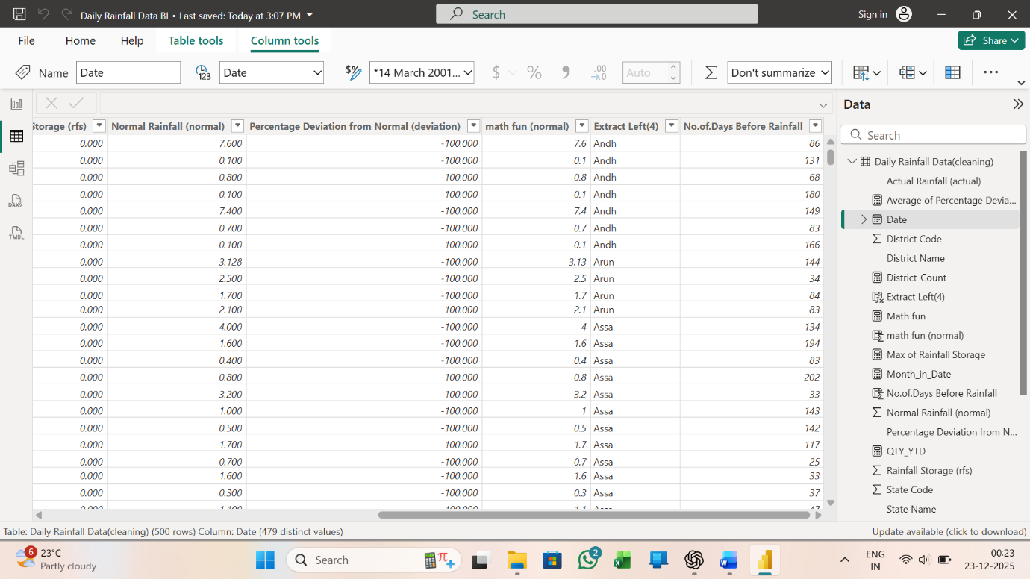

Analysis and Visualizations (Power BI):
Multiple Visualizations based on problem statement:
- State vs Actual Rainfall using Map visual
- Average of percentage deviation by State name using clustered chart
- Count of rainfall status by month and date using waterfall chart
- Count of rainfall status by state name using pie chart
- This visual using button slicer
- Average of state code and count of percentage deviation from normal by state name using KPI chart
- Max of Rainfall storage and average of State code using Gauge
- Count of state code by quarter, month and day using Clustered bar chart
- This visual using List slicer and using bookmark
- Create Table and Matrix using Button slicer and drill through
- Finally Create Daily Rainfall Data Report.

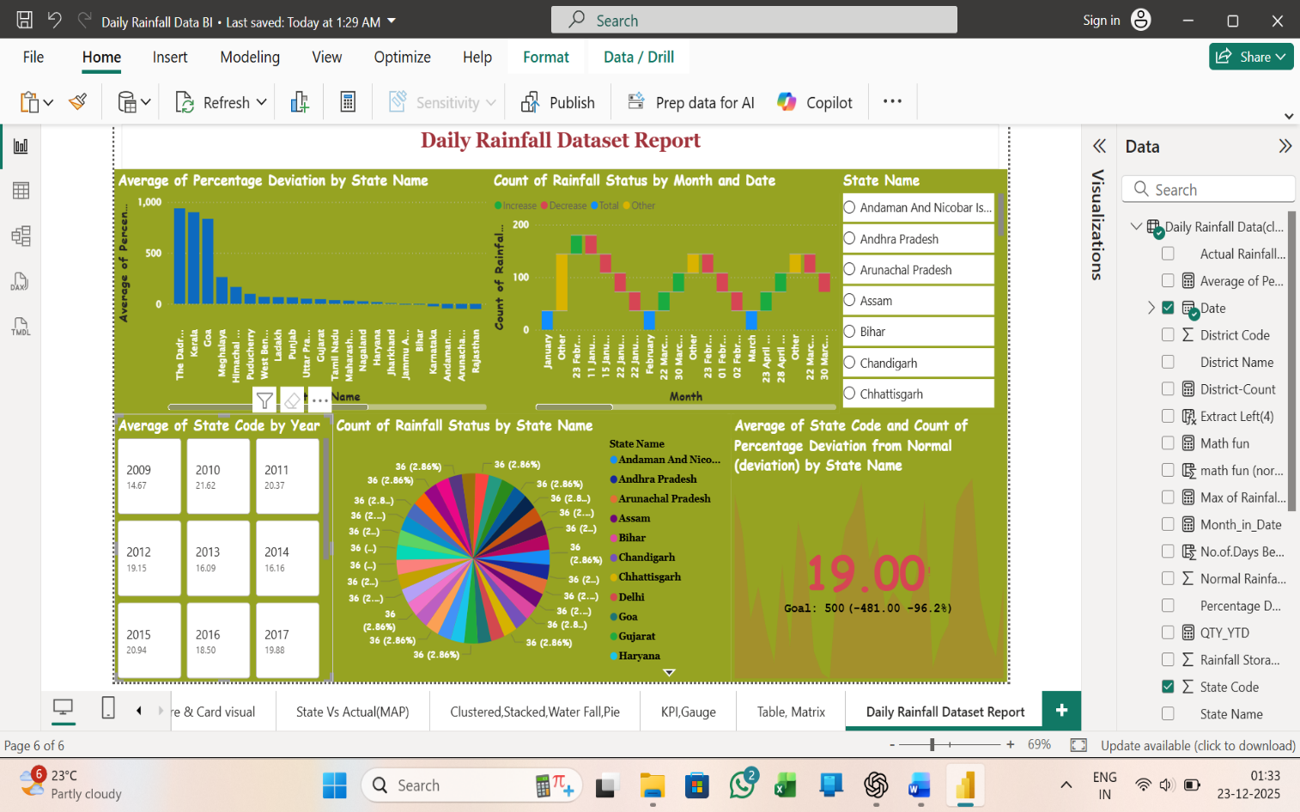

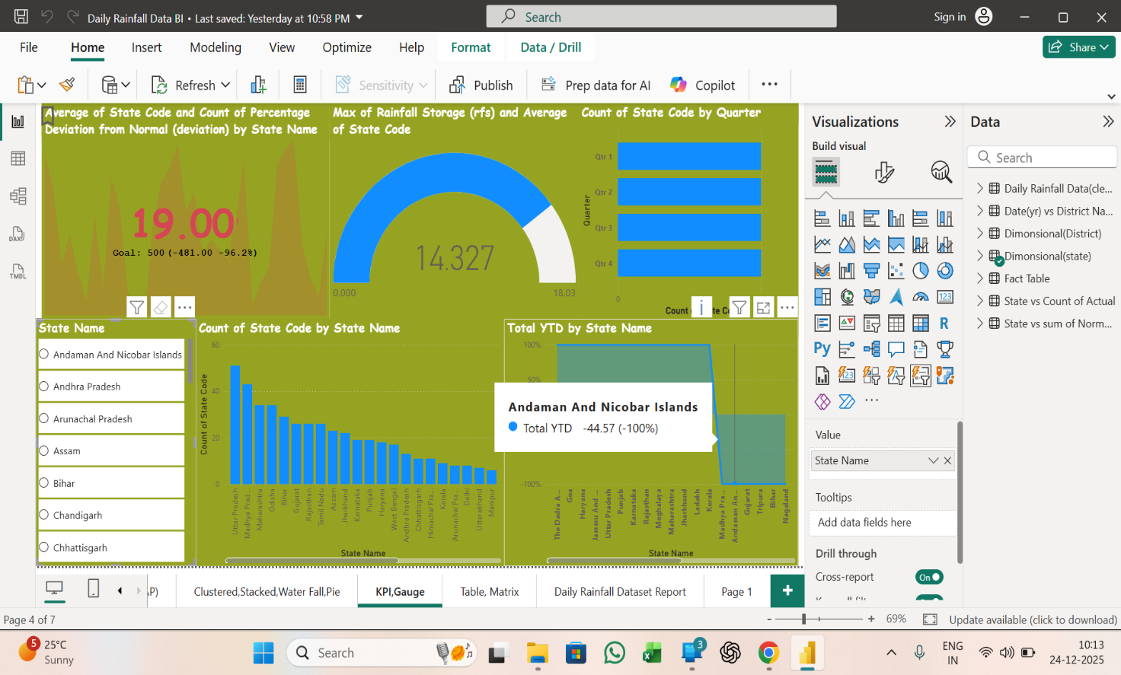

Insights and Conclusions:
Key Findings:
- Highest rainfall is observed during the monsoon season (June–September).
- Lowest rainfall occurs during summer months (March–May).
- Rainfall peaks are strongly influenced by seasonal patterns, especially the southwest monsoon.
- Flood preparedness measures are required in high rainfall districts.
- Farmers should plan crop cycles based on predicted rainfall trends.
- To understand high actual rainfall distribution over time (05/October/2009) and location (Maharashtra/Mumbai Suburban).
- To identify normal rainfall levels (0.00) and extreme values (29.800).
- Compare high-rainfall (27/July/2016) and (Maharashtra/Ratnagiri), actual rainfall (6.910) but normal rainfall (29.800).
- Number of rainy days 212
- Number of dry days 288 (0 mm rainfall)
Water Resource Management
- Decide how much water to store or release
- Plan reservoir and dam operations
Flood Risk Management
- Identify high-risk periods and locations
- Plan preventive measures
Agricultural Planning
- Decide crop selection and sowing time
- Optimize irrigation schedules
Conclusions:
Overall, this study demonstrates that daily rainfall data is valuable for weather forecasting, agricultural planning, water conservation, and disaster management, supporting informed decision-making and sustainable planning. The analysis of the daily rainfall dataset reveals that rainfall patterns are highly seasonal and strongly influenced by monsoon period.

